Prevalence Evaluation of Dental Plaque Causing Streptococcus mutans by Direct Molecular Method
among a Group of University of Kufa Students

Assistant Professor Dr. Raed Ali Hussein Shabaa
Dept. Laboratory Investigations, Faculty of Sciences, Kufa University.
Correspondence should be sent to: raaed.aboshibaa@uokufa.edu.iq

Summary:
Dental caries is recognized as one of the most infectious diseases worldwide. The most cariogenic bacteria in dental plaque are Streptococcus mutans. S. mutans is present in oral flora and has been demonstrated to be a causative specialist for dental caries because of its capacity to metabolize fermentable carbohydrate into organic acids. A developed PCR method, which is called "Nested PCR" allows more sensitive detection of pathogenic bacteria. The results of direct Nested-PCR test showed that from all the 57 dental plaque samples, 43 (75%) had Streptococcus spp. from which 38 (66%) had Streptococcus mutans.

الخلاصة:
يعد تسوس الاسنان احد اكثر الامراض المعدية انتشارا في العالم. تعتبر البكتريا Streptococcus mutans أكثر الانواع البكتيرية المسوسة للاسنان ، و قد اعتبر هذا النوع هو المتخصص في احداث تسوس الاسنان بسبب قابليته على تخمير الكاربوهيدرات الى احماض عضوية. تتيح احد الطرق المطورة من PCR و التي تدعى "Nested PCR" الى اعطاء تشخيص حساس للبكتري الممرضة. أضهرت نتائج "Nested PCR" انه من بين كل عينات تسوس الاسنان التي جمعت خلال هذه الدراسة و البالغة 57 عينة ، 43 (75%) كانت تحتوي Streptococcus spp منها 38 (66%) احتوت على Streptococcus mutans.

1. Introduction:
Dental caries is recognized as one of the most infectious diseases worldwide (1). The most cariogenic bacteria in dental plaque are Streptococcus mutans (2, 3). S. mutans is present in oral flora and has been demonstrated to be a causative specialist for dental caries because of its capacity to metabolize fermentable carbohydrate into organic acids. These acids can cause a fall in pH, which can lead to an increase of enamel solubility that is dental caries (4). S. mutans cells attached to teeth as part of a biofilm (dental plaque) may exhibit a distinct mode of growth which differs from that of planktonic cells, and this distinct mode of growth can be characterized by an increased resistance to antibiotics as well as by differential gene expression (5).
Expanding resistance of bacterial pathogens to regularly utilize antibiotics has turned into general human concern. The spread of antibiotic resistance is causing fatalities, as well as a high financial inconvenience. In low economic nations, antibiotic resistance is considered to be more prevalent than in the developed countries (6). In 2012 investigators have reported a significant level of penicillin resistance 13.4% of 550 oral streptococcal clinical isolates, out of 50 isolates of S. mutans 14% were resistant to penicillin (7). According to the study conducted in 2014, 38 isolates of S. mutans showed a complete resistance to penicillin and ampicillin (8).
S. mutans is the most prevailing species, high in rank than other streptococci (9). S.mutans is a facultative anaerobic, Gram-positive cocci bacterium (10) which appears in chains on Gram stain (11). One feature of this organism is it develops deep convex colonies on mitis salivarius agar. It has homofermentative property plus it is highly aciduric compared with the other alternative oral streptococci (12). By utilizing an enzyme glucosyl transferase S.mutans produces an extracellular polysaccharide from sucrose which causes dental caries. This extracellular substance possesses α [1-3] glucose linkage which helps in the attachment of the bacterium. Furthermore this polysaccharide aims in supplying energy during deficiency of any extraneous carbohydrate. S. mutans also generates Lipo Teichoic Acid that precisely adheres to the external enamel thus assisting the progress of colonization (13). It attaches to the tooth superficially, break down sugar for energy, decrease the pH, makes the surrounding acidic and this causes demineralization of the external structures of the tooth like enamel and dentine and sometimes in the lack of prior medication the mechanism advances ultimately developing dental caries (10). Hence, S. mutans is not only the basic bacterium engaged in the development of plaque but also for the commencement of dental caries (11).
Common methods of detection and characterization of pathogenic bacteria from the oral cavity are conventional especially culture methods, which are used to identify bacterial pathogens in dental plaque samples. Culture techniques are limited in their sensitivity and specificity, that 50% of oral micro-flora does not grow on culture media in the laboratory (14, 15). Molecular biology methods have been developed to overcome culture problems. Polymerase chain reaction (PCR) is now used in bacterial identification in environmental and clinical specimens. PCR methods are more sensitive and specific, and faster than conventional methods in bacterial determination. They allow the detection of viable and nonviable microorganisms, and consume less time and effort than conventional methods. A developed PCR method, which is called "Nested PCR' allows more sensitive detection of pathogenic bacteria. This method consists of first-step amplification with universal primers. The amplified products are used as template in second-step amplification, where species specific primers are used (16).
The aim of this study is to detect the most cariogenic bacteria in plaque samples taken from different teeth sites by using Nested PCR method to specifically detect Streptococcus mutans.

2. Materials and Methods:
2.1: Dental plaque sample collection and preparation
Fifty seven plaque samples formed on healthy enamel surfaces of 57 students in the University of Kufa (22–28 years) were collected. No student had taken antibiotics for at least 4 weeks prior to sampling. Sterile explorers were used to collect dental plaque. Plaque samples were stored in 1.5 ml sampling tubes at -20˚C prior to analysis.
2.2: DNA isolation:
Plaque samples were dispersed by vortex for 30 seconds in phosphate buffer saline (pH 7.5). Genomic DNA was extracted with the Wizard® Genomic DNA Purification Kit (Promega, USA) for isolating Genomic DNA from Gram positive bacteria. According to the kit manual each sample tube were centrifuged at 13,000–16,000 × g for 2 minutes to pellet the cells and the supernatant was removed, then 10mg/ml lysozyme (Sigma) were added to the resuspended cell pellet, and gently pipeted to mix. The purpose of this pretreatment is to weaken the cell wall so that efficient cell lysis can take place, and then proceeding with the kit protocol.
2.3: Detection of The Presence of Streptococcus mutans Using Nested PCR assay:
Polymerase Chain Reaction, using primer pair specific to 16S rDNA specific to Streptococcus, was performed to detect Streptococcus. The primers synthesized by AccuOligo® Bioneer Corporation USA (Table 1). The target sequence of 16S rDNA was amplified according to the Experimental Protocol of AccuPower® TLA PCR PreMix tube, the PCR reaction mixture was performed using 5 µl of the template DNA, 4 µl of each primer (10pmole/µl, 2 µl forward and 2 µl reverse), were added to each AccuPower® TLA PCR PreMix tube. Distilled water was added to the tubes to a final volume of 20 µl.
The PCR program consisted of initial denaturation at 95 ºC for 15 min, and 35 cycles involving denaturation at 94 ºC for 1 min, and annealing at 55 ºC for 1 min, and extension at 72 ºC for 1.5 min followed by a final extension at 72 ºC for 10 min. All reaction mixtures were held at 4°C.
The second nested PCR reaction was done for the detection of Streptococcus mutans by using species specific primer based on the 16S rDNA (16). The PCR premix and program is identical to the one used in the detection of Streptococcus genus in the first reaction.

Table 1: Primers that were used in this study
Primer set | Sequence (5’→3’) | bp | Reference
S. spp. | (F) AGA GTT TGA TCC TGG CTC AG  (R) TAC GGG TAC CTT GTT ACG ACT T | 1505 | Sato et al (17)
S.mutans | (F) GGT CAG GAA AGT CTG GAG TAA AAG GCTA  (R) GCG TTA GCT CCG GCA CTA AGC C | 282 | Rupf et al (18)

2.4: Electrophoresis:
The PCR products were electrophoresed through 1% agarose (Sigma Chemical Co., St. Louis, Mo.) dissolved in Tris-borate-EDTA buffer TBE (0.1 M Tris, 0.09 M boric acid, 0.001 M EDTA pH 8.4), stained with ethidium bromide. Electrophoresis was conducted at 80 V for 60 min; the bands were visualized with a UV transilluminator.
3: Results:
3.1: Detection of the presence of S. mutans using Nested PCR
Total genomic DNA, which was directly isolated from plaque samples, was subjected to N-PCR reactions. The detection of the genus Streptococci was performed by using primer pair specific to 16s rDNA of the genus Streptococci. The positive amplified PCR product (1505 bp size), representing Streptococcus genus, was detected in 43 samples (Fig. 1).
In the second reaction, the detection of the S. mutans was done by using 16s rDNA primer pair specific to the species S. mutans. The species S.mutans was detected in 38 samples. (Fig. 2) represents the presence of the amplified PCR product (282 bp).

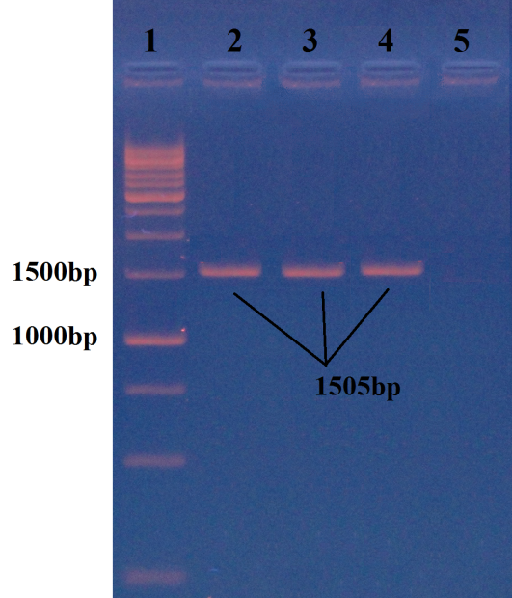
Figure 1: 1505 bp PCR products for 16s rDNA specific to Streptococcus spp. Lane 1: (1kb) DNA ladder; Lane 2-4: positive result; Lanes 5: negative result.
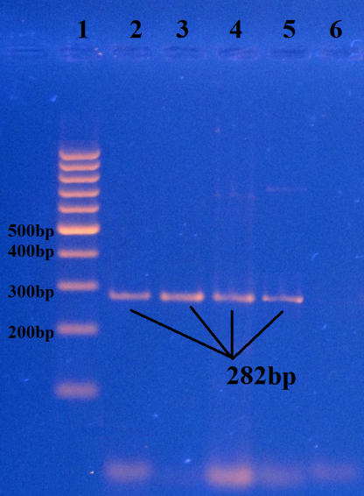
Figure 2: 282 bp PCR product of the species Streptococcus mutans. Lane 1: (100 bp ladder); Lane 2-5: positive result; Lane 6: negative result.

4. Descution:
The results of direct Nested-PCR test showed that from all the 57 dental plaque samples, 43 (75%) had Streptococcus spp. from which 38 (66%) had Streptococcus mutans.
The results of this study confirm the disadvantages of conventional method such as poor specificity and sensitivity; detection of only viable culturable bacteria - and that they are time consuming and laborious. On the other hand, PCR methodology provides a more sensitive mean of detection of putative bacterial species even non-culturable bacteria if compared with conventional culture techniques (19). Also it is able to detect low numbers of bacterial species, being quick and relatively simple to perform. Moreover, a PCR assay has been found to be suitable for the specific detection and identification of human cariogenic bacteria like Streptococcus mutans (16).
Conclusions:
PCR methodology provides a more sensitive mean of detection of putative bacterial species even non-culturable bacteria if compared with conventional culture techniques.
Recommendations:
Further studies Should be done to evaluate the efficiency of molecular methods in the identification of dental caries bacteria other than Streptococcus spp.

References:
- Takada K, Fujita K, Ikemi T, Osgood RC, Childers NK, Michalek SM. Differentiation of banding patterns between Streptococcus Okada T, mutans and Streptococcus sobrinus isolates in rep-PCR using ERIC primer. J Oral Microbiol, 2011; 3:7190.
- Rosan B and Lamont R J. Dental plaque formation. Journal of Microbes and Infection, 2000; 2: 1599-1607.
- Hoshino T, Kawaguchi M, Shimizu N, Hoshino N, Ooshima T and Fujiwara T. PCR detection and identification of oral streptococcus in saliva samples using gtf genes. Journal of Diagnostic Microbiology and Infectious Disease. 2003;48: 195-199.
- Hui SHH, Ariffin Z, Alam MK. In Vitro Study of Antibacterial Properties of Endodontic Sealers and Medications towards Streptococcus mutans and Enterococcus feacalis. International Medical Journal, 2013; 20(4):493-495.
- Watnick, P. & Kolter, R. (2000). Biofilm, city of microbes. J Bacteriol 182, 2675–2679.
- Kapi A. The evolving threat of antimicrobial resistance: Options for action. Indian J Med Res, 2014; 139(1):182.
- Pasquantonio G, Condò S, Cerroni L, Bikiqu L, Nicoletti M, Prenna M, Ripa S. Antibacterial activity of various antibiotics against oral streptococci isolated in the oral cavity. Int J Immunopathol Pharmacol, 2012; 25(3):805-809.
- Dhamodhar P, Sreenivasa Murthy, Channarayappa, Shanthakumar SS, Indiresha HN. Prevalence, characterization and heterogeneity studies on Streptococcus mutans isolated from Bangalore urban population. Int J Pharm Bio Sci, 2014; 5(3):122–128.
- Gross EL, Beall CJ, Kutsch SR, Firestone ND, Leys EJ, et al Beyond Streptococcus mutans: Dental Caries Onset Linked to Multiple Species by 16S rRNA Community Analysis. Plos One, 2012; 7(10):1-10.
- El Sherbiny GM Control of growth Streptococcus mutans isolated from saliva and dental caries. Int.J.Curr.Microbiol.App.Sci, 2014; 3(10): 1-10.
- Todar K. The Normal Bacterial Flora of Humans .Online textbook of Bacteriology. Accessed on 8 th April.2015. http:/textbook of bacteriology. net/ normal flora_3.html.
- Rajendran R, Sivapathasundaram B. Shafer's Textbook of Oral Pathology. 7 th ed. Elsevier 2014.
- Rao A. Principles and Practice of Pedodontics. 2nd ed. Jaypee Brothers; 2008.
- Paster B J, Boches S K, Galvin J L, Ericson R E, Lau C N, Levanos V A, Sahasrabudhe A and Dewhirst F E.. Bacterial diversity in human subgingival plaque. Journal of Bacteriology, 2001; 183: 3770-3783.
- Munson M A, Banerjee A, Watson T F and Wade W G.. Molecular analysis of the microflora associated with dental disease. Journal of Clinical Microbiology, 2004; 42: 3023-3029.
- Sato T, Matsuyama J, Kumagai T, Mayanagi G, Yamaura M, Washio J and Takahashi N. Nested PCR for detection of mutans Streptococci in dental plaque. Letters in Applied Microbiology, 2003; 37: 66-69.
- Sato, T., Sato, M., Matsuyama, J. & Hoshino, E. PCRrestriction fragment length polymorphism analysis of genes coding for 16S rRNA in Veillonella spp. Int J Syst Bacteriol, 1997; 47, 1268–1270.
- Rupf, S., Merte, K., Eschrich, K., Sto¨ sser, L. & Kneist, S. Peroxidase reaction as a parameter for discrimination of Streptococcus mutans and Streptococcus sobrinus. Caries Res, 2001; 35, 258–264.
- Rawashdeh R.Y., Malkawi H. I., Al-Hiyasat A. S. and Hammad M. M. A Fast and Sensitive Molecular Detection of Streptococcus mutans and Actinomyces viscosus from Dental Plaques Jordan Journal of Biological Sciences, 2008; 3(1):135-13

